## Library Module – Shared Library

1. Create 3 files as below.
   * libapplication.c – will contain main() and will invoke functions in cal_utility.c
   * cal_utility.c – will contain atleast 2 or more functions [ You may add definitions of the functions in this file ]
   * cal_utility.h – will contain the extern declarations/prototypes of the functions in cal_utility.c

libapplication.c

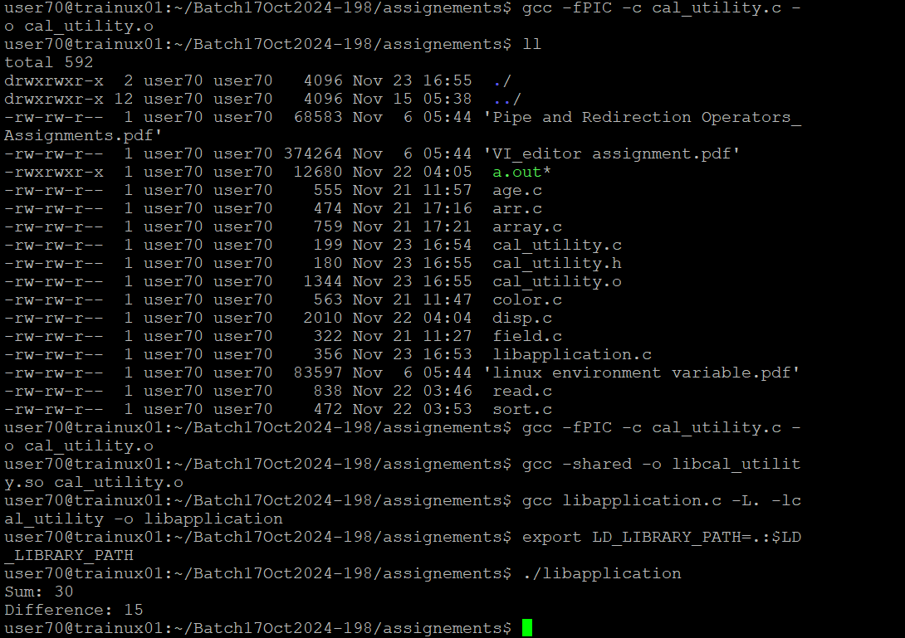

cal_utility.c

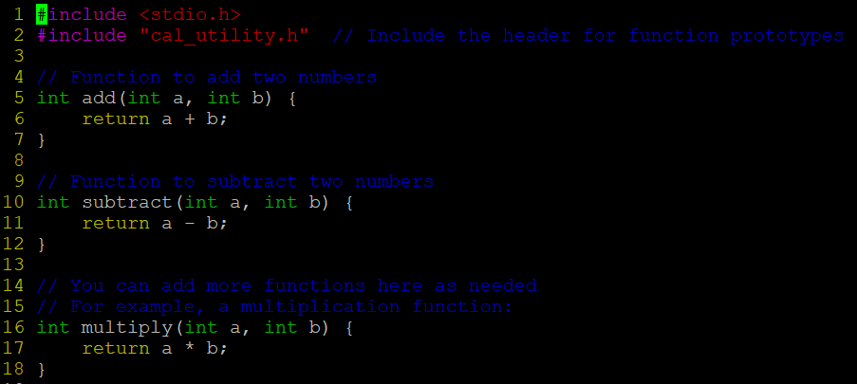

cal_utility.h

1. Refer the steps for shared library and create a shared library comprising of cal_utility.c,.h files

**Ans: gcc -FPIC -c calutility.c**

**gcc -shared -o libcalutility.so calutility.o**

1. Create an executable using shared library.

**ANS:** **gcc -o application libapplication.c cal_utility.c**

1. Execute the application created step 3.

**Ans: ./application**

